**BANK LOAN REPORT QUERRY DOCUMENT**

1. **BANK LOAN REPORT SUMMARY**

# **KPI’S**

**TOTAL LAON APPLICATION**

SELECT COUNT(id) AS Total_Applications FROM dbo.financial_loan;



**MTD_TOTAL_APPLICATION**

SELECT COUNT(*) AS MTD_Total_Applications

FROM dbo.financial_loan

WHERE MONTH(issue_date) = 12 AND YEAR(issue_date) = 2021;



**PMTD LOAN APPLICATIONS**

SELECT COUNT(*) AS PMTD_Total_Applications

FROM dbo.financial_loan

WHERE MONTH(issue_date) = 11 AND YEAR(issue_date) = 2021;



**MONTH ON MONTH PERCENTAGE CALCULATION**

WITH CurrentMonth AS (

SELECT COUNT(*) AS MTD_Total_Applications

FROM dbo.financial_loan

WHERE MONTH(issue_date) = 12 AND YEAR(issue_date) = 2021

),

PreviousMonth AS (

SELECT COUNT(*) AS PMTD_Total_Applications

FROM dbo.financial_loan

WHERE MONTH(issue_date) = 11 AND YEAR(issue_date) = 2021

)

SELECT

CASE

WHEN PreviousMonth.PMTD_Total_Applications = 0 THEN NULL

ELSE ((CurrentMonth.MTD_Total_Applications - PreviousMonth.PMTD_Total_Applications) / CAST(PreviousMonth.PMTD_Total_Applications AS FLOAT)) * 100

END AS Month_Over_Month_Percentage

FROM

CurrentMonth,

PreviousMonth;



**TOTAL FUNDED AMOUNT**

SELECT SUM(loan_amount) AS Total_Funded_Amount FROM dbo.financial_loan;



**MTD TOTAL FUNDED AMOUNT**

SELECT SUM(loan_amount) AS MTD_Total_Loan_Amount FROM dbo.financial_loan

WHERE MONTH(issue_date) = 12 AND YEAR(issue_date) = 2021;



**PMTD TOTAL FUNDED AMOUNT**

SELECT SUM(loan_amount) AS PMTD_Total_Loan_Amount FROM dbo.financial_loan

WHERE MONTH(issue_date) = 11 AND YEAR(issue_date) = 2021;



**MONTH OVER MONTH PERCENTAGE CHANGE**

WITH CurrentMonth AS (

SELECT SUM(loan_amount) AS MTD_Total_Funded_Amount

FROM dbo.financial_loan

WHERE MONTH(issue_date) = 12 AND YEAR(issue_date) = 2021

),

PreviousMonth AS (

SELECT SUM(loan_amount) AS PMTD_Total_Funded_Amount

FROM dbo.financial_loan

WHERE MONTH(issue_date) = 11 AND YEAR(issue_date) = 2021

)

SELECT

CASE

WHEN PreviousMonth.PMTD_Total_Funded_Amount = 0 THEN NULL

ELSE ((CurrentMonth.MTD_Total_Funded_Amount - PreviousMonth.PMTD_Total_Funded_Amount) / CAST(PreviousMonth.PMTD_Total_Funded_Amount AS FLOAT)) * 100

END AS Month_Over_Month_Percentage

FROM

CurrentMonth,

PreviousMonth;



**TOTAL AMOUNT RECIVED**

SELECT SUM(total_payment) AS Total_Amout_Recived FROM dbo.financial_loan;



**MTD TOTAL AMOUNT RECEIVED**

SELECT SUM(total_payment) AS MTD_Total_Amout_Recived FROM dbo.financial_loan

WHERE MONTH(issue_date) = 12 AND YEAR(issue_date) = 2021;



**PMTD TOTAL AMOUNT RECEIVED**

SELECT SUM(total_payment) AS MTD_Total_Amout_Recived FROM dbo.financial_loan

WHERE MONTH(issue_date) = 11 AND YEAR(issue_date) = 2021;

**AVG INTEREST RATE**

SELECT ROUND(AVG(int_rate),4) * 100 AS Avg_Interest_Rate FROM dbo.financial_loan;



**MTD AVERAGE INTEREST RATE**

SELECT ROUND(AVG(int_rate),4) * 100 AS MTD_Avg_Interest_Rate FROM dbo.financial_loan

WHERE MONTH(issue_date) = 12 AND YEAR(issue_date) = 2021;



**PMTD AVERAGE INTEREST RATE**

SELECT ROUND(AVG(int_rate),4) * 100 AS PMTD_Avg_Interest_Rate FROM dbo.financial_loan

WHERE MONTH(issue_date) = 11 AND YEAR(issue_date) = 2021;



MoM percentage change

-- Subquery to calculate the average interest rate for December 2021

WITH December2021 AS (

SELECT ROUND(AVG(int_rate), 4) * 100 AS Avg_Interest_Rate

FROM dbo.financial_loan

WHERE MONTH(issue_date) = 12 AND YEAR(issue_date) = 2021

),

-- Subquery to calculate the average interest rate for November 2021

November2021 AS (

SELECT ROUND(AVG(int_rate), 4) * 100 AS Avg_Interest_Rate

FROM dbo.financial_loan

WHERE MONTH(issue_date) = 11 AND YEAR(issue_date) = 2021

)

-- Main query to calculate the MoM percentage change

SELECT

December2021.Avg_Interest_Rate AS MTD_Avg_Interest_Rate,

November2021.Avg_Interest_Rate AS PMTD_Avg_Interest_Rate,

((December2021.Avg_Interest_Rate - November2021.Avg_Interest_Rate) / November2021.Avg_Interest_Rate) * 100 AS MoM_Percent_Change

FROM

December2021, November2021;



**AVERAGE DTI**

SELECT ROUND(AVG(dti),4) * 100 AS Avg_DTI FROM dbo.financial_loan;



**MTD AVERAGE DTI**

SELECT ROUND(AVG(dti),4) * 100 AS MTD_Avg_DTI FROM dbo.financial_loan

WHERE MONTH(issue_date) = 12 AND YEAR(issue_date) = 2021;



**PMTD AVERAGE DTI**

SELECT ROUND(AVG(dti),4) * 100 AS PMTD_Avg_DTI FROM dbo.financial_loan

WHERE MONTH(issue_date) = 11 AND YEAR(issue_date) = 2021;



**GOOD LOAN ISSUED**

**Good Loan Percentage**

SELECT (COUNT(CASE WHEN loan_status = 'Fully Paid' OR loan_status = 'Current' THEN id END)* 100)

/ COUNT(id) AS Good_loan_percentage

FROM dbo.financial_loan;



**Good Loan Application**

SELECT COUNT(id) As Good_Loan_Applications FROM dbo.financial_loan

WHERE loan_status = 'Fully Paid' OR loan_status = 'Current';



**Good Loan Funded Amount**

SELECT SUM(loan_amount) AS Good_Loan_Funded_Amount FROM dbo.financial_loan

WHERE loan_status = 'Fully Paid' OR loan_status = 'Current';



**Good Loan Received Amount**

SELECT SUM(total_payment) AS Good_Loan_Recived_Amount FROM dbo.financial_loan

WHERE loan_status = 'Fully Paid' OR loan_status = 'Current';



**Bad Loan Percentage**

SELECT (COUNT(CASE WHEN loan_status = 'Charged Off' THEN id END)* 100)

/ COUNT(id) AS Bad_loan_percentage

FROM dbo.financial_loan;



**Bad Loan Application**

SELECT COUNT(id) As Bad_Loan_Applications FROM dbo.financial_loan

WHERE loan_status = 'Charged Off' ;



**Bad Loan Funded Amount**

SELECT SUM(loan_amount) AS Bad_Loan_Funded_Amount FROM dbo.financial_loan

WHERE loan_status = 'Charged Off';



**Bad Loan Recived Amount**

SELECT SUM(total_payment) AS Bad_Loan_Recived_Amount FROM dbo.financial_loan

WHERE loan_status = 'Charged Off';



**LOAN STATUS**

SELECT

loan_status,

COUNT(id) AS Total_Loan_Application,

SUM(loan_amount) AS Total_Funded_Amount,

SUM(total_payment) AS Total_Amount_Recived,

ROUND(AVG(int_rate * 100),2) AS Interest_Rate,

AVG(dti* 100) AS DTI

FROM dbo.financial_loan

GROUP BY loan_status;

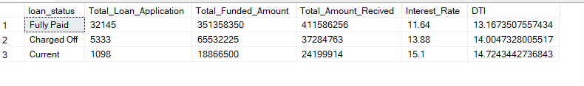

**MTD toal amount funded and recived.**

SElECT

loan_status,

SUM(loan_amount) as MTD_Total_Funded_Amount,

SUM(total_payment) as MTD_Total_Amount_Recived

from dbo.financial_loan

where month(issue_date) = 12

group by loan_status;

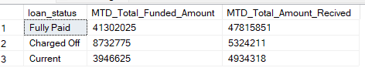

1. **BANK LOAN REPORT | OVERVIEW**

**MONTH**

select

month(issue_date) as Month_Number,

datename(month, issue_date) as Month_Nmae,

count(id) as Total_Loan_Application,

sum(loan_amount) as Total_Funded_Amount,

sum(total_payment) as Total_Recived_Amount

from dbo.financial_loan

group by month(issue_date), datename(month, issue_date)

order by month(issue_date)

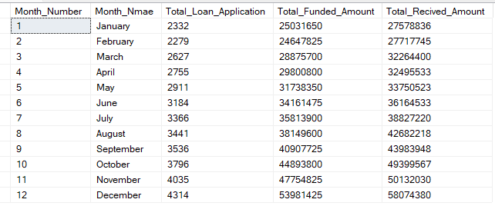

**STATE**

select

address_state,

count(id) as Total_Loan_Application,

sum(loan_amount) as Total_Funded_Amount,

sum(total_payment) as Total_Recived_Amount

from dbo.financial_loan

group by address_state

order by sum(loan_amount) desc;

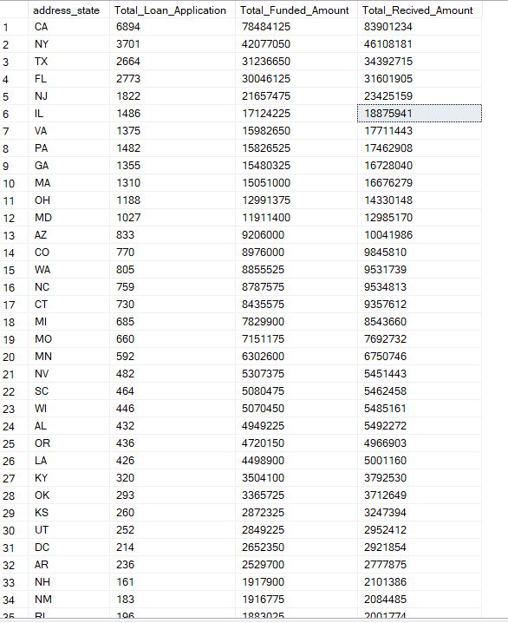

**TERM**

select

term,

count(id) as Total_Loan_Application,

sum(loan_amount) as Total_Funded_Amount,

sum(total_payment) as Total_Recived_Amount

from dbo.financial_loan

group by term

order by term;

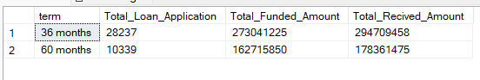

**EMPLOYEE LENGTH**

select

emp_length,

count(id) as Total_Loan_Application,

sum(loan_amount) as Total_Funded_Amount,

sum(total_payment) as Total_Recived_Amount

from dbo.financial_loan

group by emp_length

order by count(id) desc;

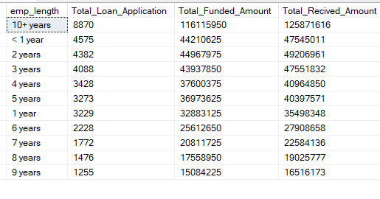

**PURPOSE**

select

purpose,

count(id) as Total_Loan_Application,

sum(loan_amount) as Total_Funded_Amount,

sum(total_payment) as Total_Recived_Amount

from dbo.financial_loan

group by purpose

order by count(id) desc;

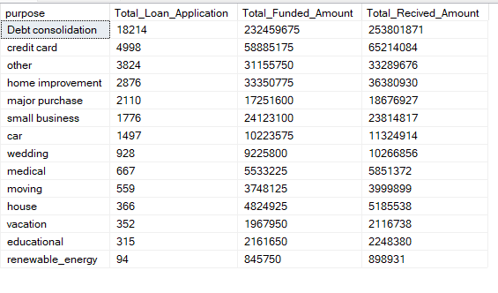

**HOMEOWNERSHIP**

select

home_ownership,

count(id) as Total_Loan_Application,

sum(loan_amount) as Total_Funded_Amount,

sum(total_payment) as Total_Recived_Amount

from dbo.financial_loan

group by home_ownership

order by count(id) desc;

